How computing can be used for the growth of film industry

Introduction

Film industry is an industry that develops day by day. This industry relies on the trend and demand of the current world. Starting from the directing of the film to the releasing computing does a major role in many occasions .

There are various genre of movies, as example, action, thriller ,mystery ,romantic ,comedy etc. For these genres they have unique aspects. So other than actors, graphical editing softwares plays a major role. One example is Computer Generated Imagery (CGI) is used to apply graphics to create special effects in movies . Graphical effects can be made by more expensive ways , but CGI is a way more cheaper alternative. Because CGI uses computer software to create images. Movies like Avatar, star wars ,The Lord of the Rings Trilogy*,* X-Men: The Last Stand*,* District 9*,* andKing Kong and in many super hero movies animations are widely used. Movies like avatar are entirely based on 3D graphics and animations.

In todays world there are many software’s that aid on film making and to make films more interactive. For example , Windows Movie Maker is a software that allows user to create and edit videos .

Another example is Pencil. This is for animations and drawings. This is widely used in armature work because it has a user friendly interface . This works with the most common animation method which is supported with IOS, windows and linux operating systems.

In IOS and in Personal computers I movie and I dvd is used to edit and create videos ,not only that using this software’s special effects can be created. For special effects of movie making there are dedicated softwares. For examples Final cut studio, Advid , Frame forge 3D , Final draft, etc.

In these softwares there are pre made formats that can be apply by anyone. Various texture packages and graphic packages are available . Final draft is a software that used to write screen plays. In here there are pre made formats that is used by popular Big motion picture companies.

Ultimately, computing made movie making to a new dimension. Computer softwares helped to advance film industry and make artist to produce their work easily .Without this computing intelligence movie making would be impossible.

Literature review

*past and present

When talking about how computing used in film industry, there is a one film that pop up in our mind. Undoubtly its Avatar by James Cameron in 2009.

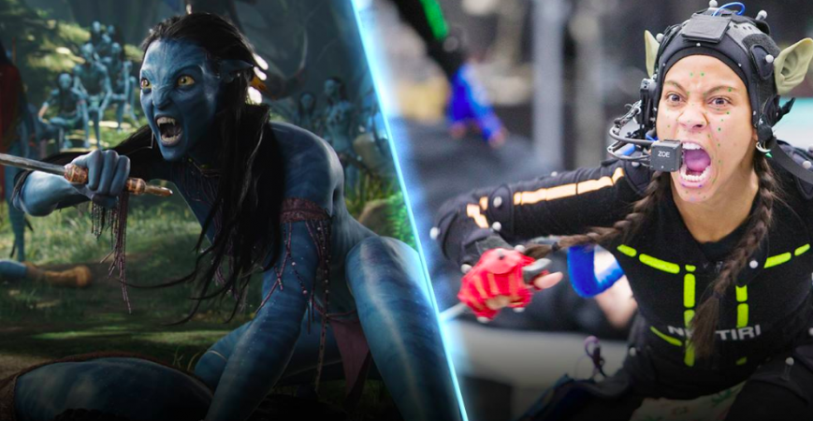

**-Transforming real world characters into animations-**

3D printing, virtual reality, depth sensors made this movie a masterpiece. The producers used a technique called the ‘image-based facial performance capture’, which required actors and actresses to put on special headgears called skull caps that were equipped with cameras. In this the facial expressions of actors were transmitted to the virtual characters from the high tech cameras . The movements caught on tape would be six times bigger, which created authenticity in the characters. By using such technology, the facial expressions of the characters can be made to change according to how the dialog was told.

Writing a screenplay for a movie in old days was a hateful task for screenwriters. Because it consumes way much time and more human energy. So it was a tired full task . But now there are various kinds of softwares and plugins. For example Final draft is a software that ease the screenplay writing. Final draft has pre made formats that related to various reputed film making companies.

In past (days before computers) editors would spend hours even days to create special effects in movies. This is how the phrase "on the cutting room floor" came about. Modern editors use a computer to go through a movie frame by frame and scene by scene and can cut and move very precisely with the click of a mouse.

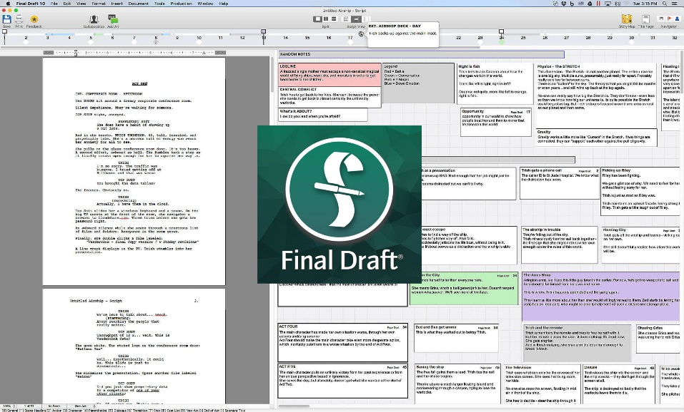

*Bad side

And also like everything else this also have its own disadvantages as well. One major disadvantage of using computing in film industry is the issue regarding copyright and privacy as well as legal issues. Due to the advancement of technology one can conduct unauthorized access to filming details, its content, rights. Throughout the years’ film industry has suffered many cybercrimes and because of it many valuable movies were financial failures.

Methodology

I got information about film industry by Wikipedia , some journals ans some research papers. I watched how computing helped in movies on youtube. To collect data about movie avatar I read blogs and backstage crew experiences.

https://www.geek.com/chips/the-computing-power-that-created-avatar-1031232/

https://www.computerworld.com.au/article/332337/how_do_they_do_it_avatar_special_effects/

Result and discussion

1)

*Problem

In movie editing as I told above editors use computer softwares. But there is major problem. These applications only can be run with high end GPU’s .Simply with high end machines. Every person cannot afford this kind of high end machines. And these softwares are licensed softwares, which cost over than a single person can afford.

*Solution

The software producers can produce softwares that can run in lower GPU machines with more servers involved. So by this the required performance of the software is served by the servers. By using lower powered engines the softwares could be run in any PCs .

2)

*Problem

Another problem is about copyright issues. Simply can be known as priracy . Software developers create softwares with much dedication and much hard work. So developers gives a value for their hard work. Most of movie editors purchase these softwares with license. But some tent to use copyright softwares with cracks used. So by this people use the softwares without the developer authorization. This is called priracy. This is an illegal activity. Because of this developers don’t tend to create new softwres